Kuwahara 另一種鄰域濾波器

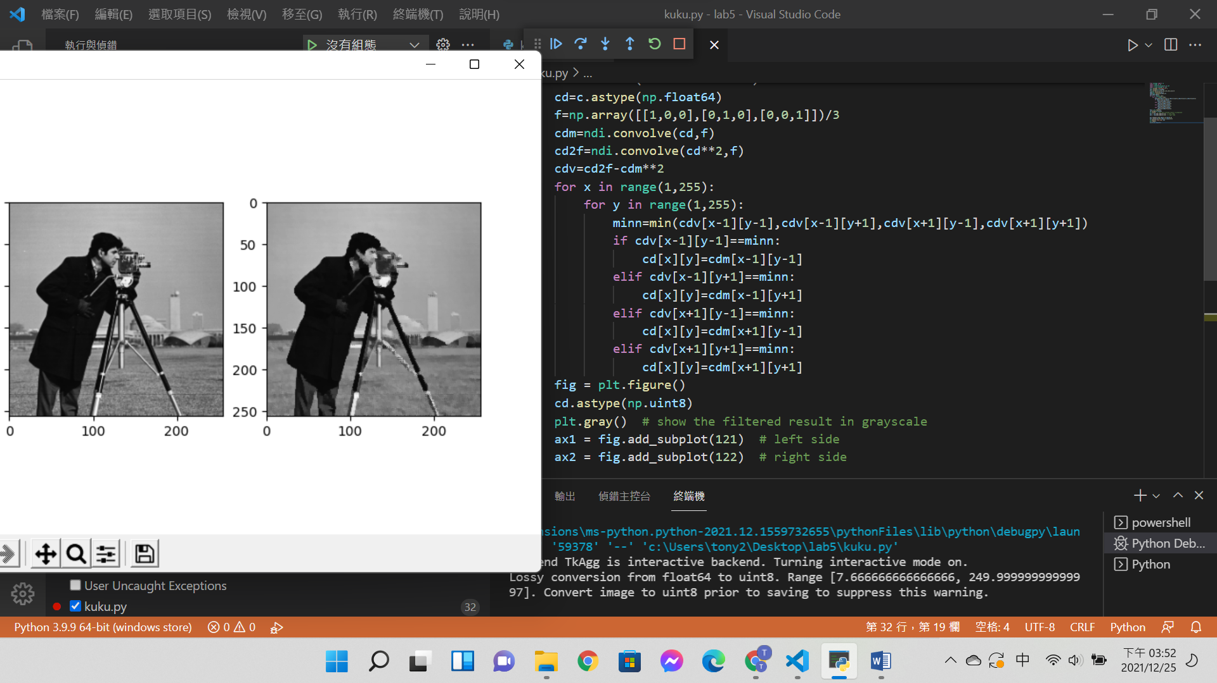code:

from skimage import io

import numpy as np

import matplotlib.pyplot as plt

import scipy.ndimage as ndi

c=io.imread('cameraman.tif')

cd=c.astype(np.float64)

f=np.array([[1,0,0],[0,1,0],[0,0,1]])/3

cdm=ndi.convolve(cd,f)

cd2f=ndi.convolve(cd**2,f)

cdv=cd2f-cdm**2

for x in range(1,255):

    for y in range(1,255):

        minn=min(cdv[x-1][y-1],cdv[x-1][y+1],cdv[x+1][y-1],cdv[x+1][y+1])

        if cdv[x-1][y-1]==minn:

            cd[x][y]=cdm[x-1][y-1]

        elif cdv[x-1][y+1]==minn:

            cd[x][y]=cdm[x-1][y+1]

        elif cdv[x+1][y-1]==minn:

            cd[x][y]=cdm[x+1][y-1]

        elif cdv[x+1][y+1]==minn:

            cd[x][y]=cdm[x+1][y+1]

fig = plt.figure()

cd.astype(np.uint8)

plt.gray()  # show the filtered result in grayscale

ax1 = fig.add_subplot(121)  # left side

ax2 = fig.add_subplot(122)  # right side

ax1.imshow(c/255,vmax=1.0,vmin=0.0)

ax2.imshow(cd/255,vmax=1.0,vmin=0.0)

io.imsave('kuwa.jpg',cd)

plt.show()

print(cd.shape[0])

心得:

雖然老師的範例程式中有一些函式有點看不太懂，但是透過kuwahara的定義還是將這個filter 做出來了。因為這次做得程式，鄰域只能是3*3，希望之後還能再修改winsize讓這個城式可以依照使用者的需求更改winsize 大小。